 **Introduction to DevOps**

**BCS/BS 6A**

Lab: 08

# GROUP MEMBERS:

MUHAMMAD SHAYAN SHAHID (2212325)

MUHAMMAD ASHAD BAIG (2212115)

Task 1: Add a Lock to the resource group and test deletion

In this task, we will add a resource lock to the resource group and test deleting the resource group.

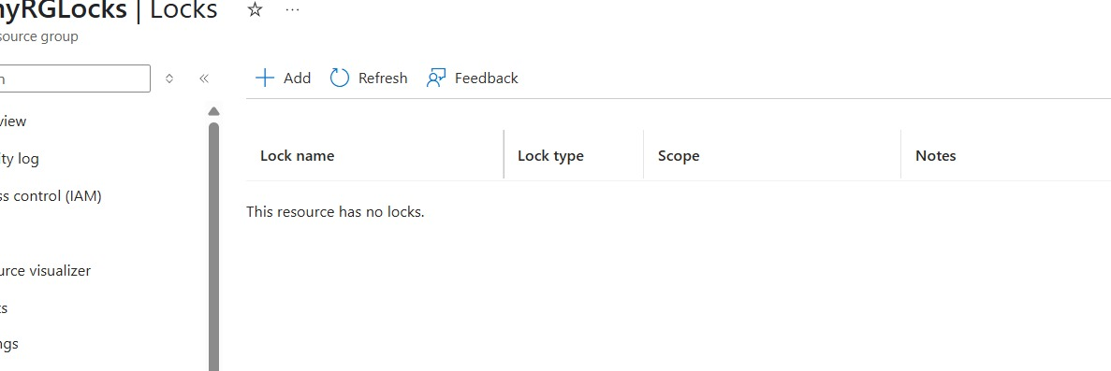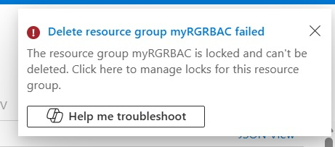

Task 2: Test deleting a member of the resource group

In this task, we will test if the resource lock protects a storage account in the resource group.

